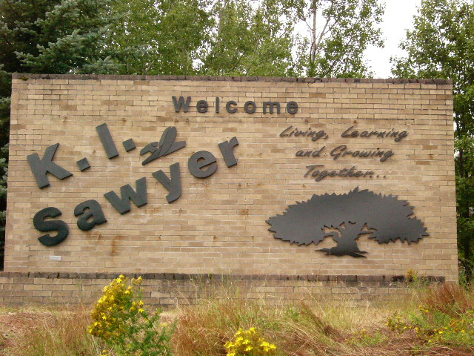

SAWYER IN REVIEW, Part II

“Eight-and-a half years ago the federal government made the decision to close K.I.Sawyer Air Force Base. The decision meant the loss of more than 4,500 jobs and a military payroll of over $100 million per year. The anticipated impact to the area and economy was almost beyond comprehension. However, many individuals and agencies did not give up on Sawyer. Rather, they saw the prospect of developing a community and creating new, diverse economic opportunities. …..It has taken a tremendous financial and personal investment of dedication and hard work, but we are building a community to be proud of, one that will continue to benefit the entire Marquette County area.”

“The Sawyer News”
Sawyer in Review, January 2002

January, 2002 through May, 2005

Sawyer Review, Part II will update the reader on progress through the last three and a half years, as K.I.Sawyer has continued to grow to a thriving community. Some have never given up on this opportunity; some have newly recognized the value of this endeavor; and others are able to see the Sawyer Community in a new, positive light.

Sawyer’s redevelopment has been an interesting and exciting venture, and even after ten years, we have just begun to tap the true potential of this area. Stay with us as the community, jobs and businesses continue to grow.

1993 - 2001
“Even if you are on the right track, you’ll get run over if you just sit there.”
Will Rogers

JANUARY
ACN Human Resources Manager reports the company will reach 165 jobs by the end of this year.

Sawyer International Airport announces increased passenger count in 2001 by 25% to 110,689.

Marquette County Board requests proposals for the former SAGE/command center and hospital building at no cost in exchange for jobs.

Several housing developers will submit proposals for remaining 622 unsold housing units at Sawyer. Previous housing sales include 198 to Red Fox Woods; 264 to K. I. Sawyer Development, Inc.; and 199 to MACASU. The Saulte Ste. Marie Tribe of Chippewa Indians received 275 units directly from the Air Force.

FEBRUARY
Sawyer Library Project continues. Volunteers move all books from the bomb bunkers and store most at the fitness center. Forsyth and West Branch Township officials agree to support a single building to serve as a learning center for Sawyer.

Free Will Baptist Church opens in the 407 Avenue A chapel.

Louisiana-Pacific Gwinn Lumber Mill processes The Tree of Hope, U. S. Capital Christmas Tree cut from the Ottawa National Forest, into lumber to be used to build Habitat for Humanity houses, including six in Marquette.

Seniors share their holidays at the Community Coordination Office—a facility owned by Sawyer Village; operated by the Sawyer Community Association and funded by the Catholic Campaign for Human Development.

MARCH
Victory Lutheran Church begins bussing residents to Marquette for bi-monthly outings, and offering weekly “Dinner and a Movie” nights.

West Branch Township requests acquisition of the former K.I.Sawyer Ski Hill. Supervised public sledding to be available for the public.

County Board votes to exclude sale of Sawyer International Airport from developer discussions.

Local developer William Perry offers $1 million cash for Sawyer’s remaining housing.

YMCA and Marquette County commit to continuing operations at the South County “Y”.

APRIL
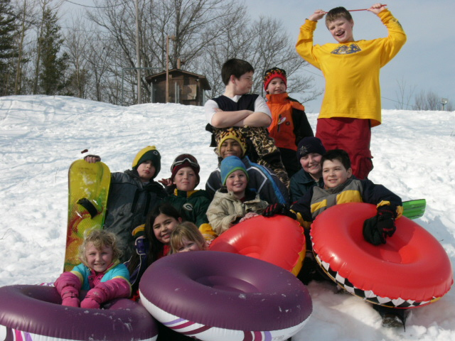
First annual Sawyer Community Association sledding party held with about 150 in attendance.

Wells Fargo Bank Sawyer branch to close in May. Bank President indicates that, “The Sawyer Store does not fit into the matrix that we have.”

Sawyer Community Association Mission Statement: To provide a voice through which the residents of Sawyer, working together, can build a vibrant, prosperous community.

MAY
American Communications Services (ACN) was honored for economic development excellence by the Michigan Economic Development Corporation. ACN, an inbound call center, is the largest single company investment in a Renaissance Zone. The company has invested an estimated $16 million.

Marquette County Sheriff’s Department takes over security detail at Sawyer International Airport. Security will be provided 16 hours a day, seven days a week.

Several businesses at Sawyer purchase their buildings, signaling a shift toward private ownership.

Sawyer International Airport’s Marquette County Aviation Wall of Honor dedicated, along with Kelly Johnson Memorial Drive, named in honor of aviation engineer Kelly Johnson.

SUMMER
Gwinn Schools offers free summer lunch program for area youth.

A two-million dollar M-94 road construction project will eliminate four road stop signs through Sawyer. Project to be completed by September.

Marquette County Board approves a swap with Road Commission. In exchange for several parcels of land, Marquette County Road Commission will receive two buildings at Sawyer—
#530 and #533, several pieces of heavy equipment, and diesel fuel with reduced mark-up.

New home owners welcomed to the community with a dessert reception hosted by the Sawyer Community Association.

Boeing 737 Technology Demonstrator aircraft visits Sawyer for a refueling stop and short inspection visit. After a one hour stop the crew loaded a box of hot pasties on board for an in-flight dinner back to Seattle.

Navy Reservists help with community library project. About 170 Navy reservists come together for a monthly weekend of training at K.I.Sawyer; they also provide volunteer services for numerous community projects.

Sawyer Children’s Library, located in temporary facilities at 1307 Eagle Street, plans grand opening for June 7.

Several thousand people attend the first annual Sawyer Aviation Expo.

The Sawyer Jr. Fun (Softball) League headed full swing into the summer softball season. With supplies donated by the YMCA, Victory Lutheran Church and Forsyth Township, and community volunteers, dozens of youth enjoy this new opportunity.

After careful consideration of three proposals for development of remaining housing units at Sawyer, the County Board accepts SLP Development’s offer of $2.5 million. SLP will take over the remaining 622 units and turn them around for private renters and homeowners. SLP investors are Frank Leckwart, Bill Pesola, Rich Sorenson and Kerry Sorenson; all are involved in other Sawyer projects.

Little Trout Lake Fishing Carnival – free fishing and fun for all children under 16 years. Event sponsored by Trout Unlimited, Michigan Department of Natural Resources and the Sawyer Community Association.

Federal Aviation Administration chooses Sawyer to continue in the Military Airport Program that assists former military airfields in their conversion to civilian use. In the prior five years the county received about $12 million. Amount of funding associated with this minimum two year extension is unknown.

Volunteers provide facelift for Stratofort Street play area.
American Communication Network (ACN) to hire fifty to sixty new employees at the Sawyer call center due to consolidation of operations in North America.

Marquette County sells three buildings and 10 acres of raw land at Sawyer to the county’s Economic Development Corporation to create an electric utility linemen training center.

SEPTEMBER
With Sawyer Village and Magdaleno Carpets supplying materials and the Naval Reserve providing manpower, the Community Coordination Office receives a new ramp for handicapped access.

Gwinn-Sawyer Veterinary Clinic expands services. Dr. Jean Wilcox received the deed to her building in May, and since then has completed some interior remodeling, including a new X-Ray room, surgery room, kennel room and treatment/exam room.

Appleton Papers, Inc., a Wisconsin based firm, signs a three year lease for office space in Sawyer’s former manpower office.

OCTOBER
K. I. Processing plans dairy plant and other ventures for Air Force heating plant facility.

K. I. Sawyer Community Association celebrates completion of first year of operation funded by the Catholic Campaign for Human Development.

A vacant building moved from Sawyer two years ago will become the Ewing Township Hall. USDA funded the building’s renovation and move.

Local volunteers again celebrate “Make a Difference Day” at Sawyer with a community clean-up.

NOVEMBER
Sawyer International Airport air traffic control tower dedicated. The tower has been vacant since 1995. Tower will be manned 365 days a year. FAA is expected to pay annual operating costs.

Victory Lutheran Church schedules “Free Give-Away Days” on a regular basis. All items are donated by people in the Sawyer community for people in the Sawyer community.

Kids-R-Us is a full-service child development center. LaTonya Redfern purchased the 48-child capacity center last spring.

Federal Transportation Security Administration announces hiring of nineteen security employees at Sawyer International Airport. Building 731 across 10th Street from the terminal will be used as security personnel headquarters.

DECEMBER
Annual community tree-lighting ceremony held at Community Coordination Office, 269 Canberra Street.

Sands Township transfers most of its K.I.Sawyer property (2,350 acres) to Forsyth Township. The donated property is located within the Renaissance Zone, generating no property tax until 2012.

New Dollar Store Plus opens as combination convenience/video rental store.

Sawyer’s Renaissance Zone which provides significant business tax benefits, is expanded to include Louisiana-Pacific facility. Sawyer Lumber sold the mill to L-P in 2000. Mill employs 189 people.

As new owner of the ski hill, West Branch Township has recently invested in hill and chalet maintenance to provide a quality recreational operation for Sawyer.

Sawyer Medical Center expands services to include Meyer Family Vision. Dr. Kroll and Dr. Khouli provide general practitioner care; Sawyer Dental Clinic offers full dental services to Medicaid recipients; Great Lakes Recovery expanded its services to Sawyer in November, offering various addiction treatments and therapy groups; and Marquette General Hospital’s Rehabilitation Services include physical therapy, hand therapy and aquatic therapy.

Sawyer Community Association continues an active role in the community with a two-person staff-- Jan Sorensen, Community Coordinator and Charles Street, Facility Manager.

“The only struggle that is lost is the one that is abandoned. NEVER GIVE UP!”
Mothers of the Plaza de Mayo

JANUARY
Recognizing differences between K.I.Sawyer and the remainder of Forsyth and West Branch Townships, the two township governments form the Sawyer Operations Authority (S.O.A.) to address interests, issues and concerns of this new unique community.

S.O.A. Board to be comprised of Joe Minelli, Forsyth Township Supervisor; Barry Bahrman, West Branch Township Supervisor; Bill Nordeen, Marquette County Board District 8 Commissioner; Jan Sorensen, representing the Sawyer residents; and Mike Prokopowicz, representing the Sawyer business community. Township alternates are Doreen Takalo, West Branch Township, and Jane Nordeen, Forsyth Township.

Marquette County Medical Care Access Coalition begins enrolling patients for free medical and dental care, provided the clients do not have insurance coverage and are considered low income. Enrollments will take place at Sawyer Medical Center.

“K.I.Sawyer” is designated as the official site name for Michigan maps.

FEBRUARY
Bell Medical Center exploring the possibility of opening a physician practice at K.I.Sawyer.

Coordination Office accommodates regular meetings of the following groups: Teen 4-H, West Branch Township Board, Seniors Group, Junior Girl Scout Troop, Commodity Food Distributors, Sawyer Community Association and others.

MARCH
Annual Community Potluck dinner sponsored by Sawyer Community Association at K. I. Sawyer Elementary School.

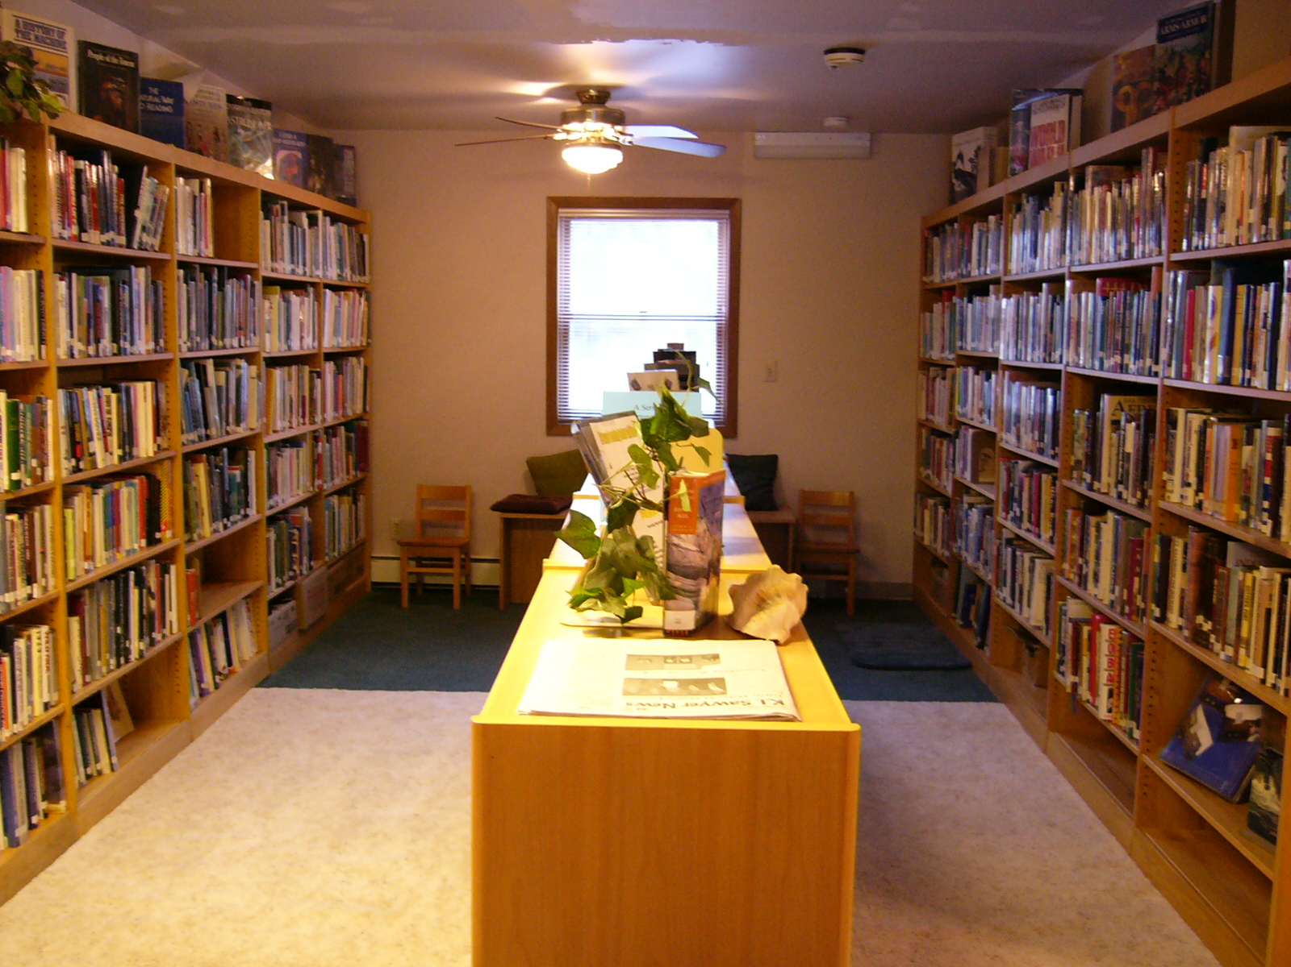

Newly renovation Sawyer Learning Center opens on Eagle Street. This truly collaborative effort of local volunteers, Forsyth Township, West Branch Township, Sawyer Operations Authority, Gwinn Area School District, Sawyer Community Association and Michigan Community Service Commission provides a safe, pleasant learning environment for residents.

Salvation Army Youth Center closed for extended period due to frozen pipes and extensive water damage.

Forsyth Senior Center also provides services to Sawyer seniors in need.

Bahrman’s Blue Ribbon Dairy begins milk processing at its Sawyer plant, with the Bahrman family dairy farm providing all raw product. The plant is located in Sawyer’s former heating plant facility.

APRIL
AMCAB Head Start, Early Head Start and MI School Readiness Programs offer their programs at Sawyer and are seeking children for preschool screenings.

Sawyer Community Association and YMCA sponsor a community Easter egg hunt for over 200 participants. The Association hosts events such as these to “build a healthy community and get people out to meet their neighbors”.

Sawyer Operations Authority hires first Executive Director, Karen Anderson who has been active in the community for several years.

MAY
Comau Pico, formerly Wisne Design and Progressive Tool and Industries, celeberates five years of operation at Sawyer. The international firm, considered an innovative leader in industrial automation, is centered near Detroit. Its Sawyer office employs twenty people.

The Naval Reserve Facility houses six full-time active duty personnel, eleven mobilized military, and approximately fifty reservists who meet once a month. Reservists have volunteered on numerous community improvement projects, including Little Trout Lake improvements, building a handicapped ramp for the Community Coordination Office, moving books and equipment for the Learning Center, roadside clean-up, etc.

SUMMER
Construction of the new K.I.Sawyer Emergency Services Building and realignment of Avenue C are both underway.

YMCA will manage Little Trout Lake for Sawyer Operations Authority. Location includes beachfront swimming, rustic tent sites, RV utility sites, laundry services, numerous recreational opportunities, a concession stand and pavilion.

Annual Community Beautification Event scheduled. Flower planting and family fun for all ages promised.

Sawyer Community Association hosts Little Trout Lake Fishing Carnival.

Michigan’s Great Outdoors Culture Tour provides “Folksongs & Footnotes”, an evening of music and stories by folklorist John Berquist, at Little Trout Lake.

Library books from the Air Force holdings that cannot be used at the K.I.Sawyer Learning Center are donated to other U.P. libraries, and remainder sold to the public, generating about $5,000 for Learning Center operation.

Marquette County named one of top ten “All America Cities” by the National Civic League. Sawyer’s re-development is mentioned in the competitive program as a positive activity.

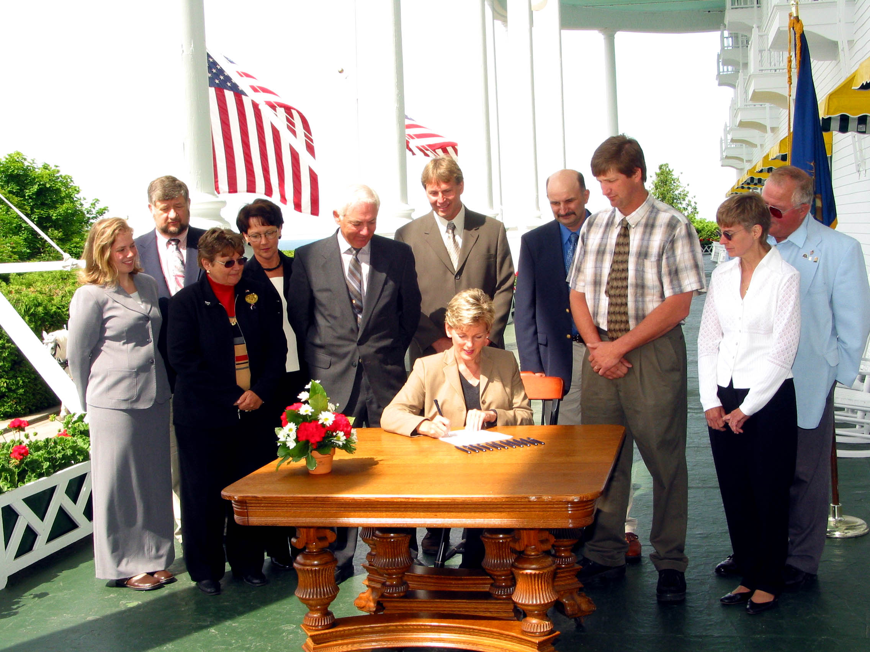

Sawyer Operations Authority Board and Director and Forsyth and West Branch Township Board members meet Governor Jennifer Granholm on the front porch of Mackinac Island’s Grand Hotel for an official signing ceremony in which Granholm signs the joint operating agreement, officially recognizing the S.O.A. as a legal entity.

Bahrman Dairy’s Grand Opening featured the Milk Mustache Mobile, Colgate Country Showdown, horse drawn carriage rides and much more family fun.

As one of K.I.Sawyer’s “oldest” traditions, annual National Night Out picnic is celebrated by the community.

SEPTEMBER
Jan Sorensen, second Community Coordinator, resigns to marry and to pursue Master’s Degree.

Marquette Community Foundation funds South County YMCA’s after-school Homework Club.

Sawyer Medical Center hosts Health Fair and Open House.

K. I. Sawyer loses Brenda and Bob Mulally, long-time Sawyer residents, business owners and community leaders, as they leave the area to be near their children.

Retired priest Father Peter Minelli, a Gwinn native, retires to Sawyer where he is elected to serve on the Sawyer Community Association Board. Asked about his involvement, Father Pete replied, “I wanted to give back to the community and was impressed with what I saw and with living here.”

Marquette County Community Corrections Program personnel utilized to help clean sidewalks and paint YMCA.

OCTOBER
Natasha Gill hired by the Sawyer Community Association as Community Coordinator. Position is funded by 3rd year of the Catholic Campaign for Human Development grant.

AmeriCorps volunteer Chris Dennis, under supervision and funding of Sawyer Operations Authority, will serve at the K.I.Sawyer Learning Center and YMCA.

Dollar Plus Store and Deli open at 130 Voodoo Avenue.

Target Stores, Inc. funds a $2,000 Literacy Program Grant for the Learning Center.

K. I. Sawyer Community Association Mission Statement – “…to provide a structure through which the residents of K. I. Sawyer, working together, can build a vibrant, prosperous community.”

NOVEMBER
Tailwinds Grill and Bar, located in the Sawyer Center, former Officers’ Club, opens for business. The extended John Eagle, Sr. family will add this operation to their Red Fox Inn and Touch & Go Food Shop at the airport.

Sue McNeill, one of K.I.Sawyer Learning Center’s most active, and longest-standing volunteers, accepted the position of Volunteer Coordinator for the Center. Position is funded by a Michigan Community Service Commission Learn and Serve Grant. McNeill, a retired school teacher and librarian, lived at Sawyer from 1972-1975 when her husband David was stationed here.

Free Will Baptist Church announces formation of AWANA Club.

Community curfew set for 11:00 p.m. for all Sawyer youth through age seventeen.

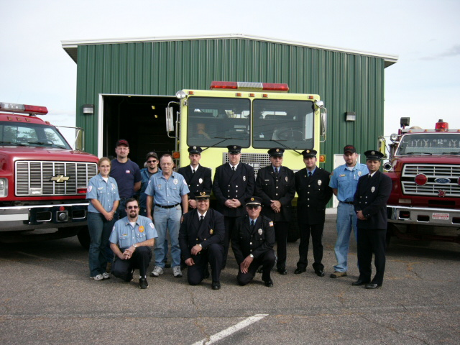

Township and County officials, local firefighters, and others gather for the dedication of the new K.I.Sawyer Emergency Services Building at 420 Avenue A. Funded by an EPA grant, owned by Marquette County, leased by Forsyth Township, with oversight by Sawyer Operations Authority, the facility will house firefighters from the Forsyth and Skandia/West Branch Fire Departments.

DECEMBER
Dwight and Joyce Sunday purchased an entire duplex at 629 and 631 Valkyrie in December, 2001. Since extensive remodeling, it has been transformed into the Sunday’s home as well as the Wild Blue Yonder Bed and Breakfast, a cozy, warm home decorated with K.I.Sawyer AFB memorabilia and photographs.

Telkite, Inc. and Aviation Facilities Company, Inc. (AFCO) notified Marquette County of their intent to close on acquisition of the SAGE Building and perform “due diligence” in studying most of the other K,I.Sawyer properties in anticipation of taking ownership or assuming leases.

Doug Swartout hired as Salvation Army Youth Center Director.

Community volunteers participate in Make a Difference Day.

Gwinn seniors tour K.I.Sawyer—bus tour, Tailwinds Grill and Bar, MACASU home, and Community Coordination Office.

Staff Sgt. Stephen Hattamer, a Sawyer resident, was killed in action in Iraq on Christmas Day. The community drew together in support of wife Karen and the three Hattamer children, as three to four hundred people packed Victory Lutheran Church for the funeral service.

JANUARY
In response to job market demands, the Midwest Skills Development Center opened in 2003. An Electrical Line Technical Program is the first program offered through the center with twenty-eight students in classroom and field training at Sawyer.

Marquette County Board entered into a contract with Telkite Technologies to sell all remaining county property outside Sawyer International Airport and lease available property within the airport. The deal includes $7 million paid as property and leases are transferred in phases from 2004 through 2009.

Two helicopters competing for the role of the next U.S. presidential chopper are being tested at Sawyer International. European Helicopter Industries and Sikorsky Company are working with a crew from the U.S. Army Technical Test Center in Fort Rucker, Alabama to test the choppers’ anti-icing and de-icing capabilities.

Telkite takes title to the former command building (SAGE building) as the first stage of their property deal with Marquette County. Telkite hopes to build a campus of high-tech and aviation- related companies at Sawyer.

FEBRUARY
Sawyer Community Association chooses to re-structure as Community Coordinator Natasha Gill steps down. Natasha will maintain her “K.I.Sawyer News” responsibilities.

Great Lakes Recovery Center, Inc. announces the opening of a Women’s Specialty Clinic in conjunction with its existing office at Sawyer Medical Center.

Work on the K. I. Sawyer video documentary continues. Goal is a full-length historical documentary beginning with Sawyer’s blueberry fields through arrival of the Air Force; military and family life and local economy during the active military years; Base closure; and community and economic re-development.

Sawyer Free Will Baptist Church officials finalize purchase chapel they occupy on Avenue A.

MARCH
Salvation Army Recreation Center, K.I.Sawyer Learning Center, K. I. Sawyer Community Association, West Branch Sledding Hill, Head Start Program, YMCA, and Sawyer Seniors promote growing number of activities and events for residents.

APRIL
As part of their sixtieth anniversary celebration Wright & Filippis donated $1,000 to each of sixty different non-profit groups throughout Michigan. K.I.Sawyer Community Association receives one of the grants to help support community events.

Marquette County Board agrees to continue subsidizing utility expenses at fitness center through December. Consideration was given to the facts that the County remains owner of the facility, and the building and its programs are critical to the community’s development.

Learning Center books number just under 15,000 and patron membership is growing.

Community Association and YMCA host Easter egg hunt and party.

MAY
Local entrepreneurs open in-home businesses—Flowers by Susan, Susan Hendrikson; M.O.M. Team, Carey Henning; Laura’s Family Daycare, Laura Brugman.

Stop-N-Shop convenience, deli and video store opens in previous Dollar Plus Store building at 130 Voodoo. New owners are Amber and Ted Finco and Amy and Mike Valle.

Local government officials and police agency reps meet with residents to address security issues. Advice: Report all suspicious activity. Keep landlords informed of neighborhood problems. Get to know your neighbors.

Telkite, Inc. names Vikki Kulju as Executive Director of its K.I.Sawyer Operations. Kulju served as Marquette County’s Marketing and Development Manager of K.I.Sawyer for past five years.

SUMMER
B3 Computers begins operation from its new headquarters in the SAGE building. The company relocated from San Diego to K. I. Sawyer where B3 will continue to build, sell and ship high quality made-to-order, desktop, notebook and server computer systems.

Gwinn-Sawyer Veterinary Clinic completely renovates clinic’s interior and exterior for a totally different look from the previous military décor. Dr. Jean Wilcox opened the clinic in October, 1995, one of Sawyer’s first businesses following Base closure, and continues a successful operation with a staff of three.

North State BMX receives 2-year licensing agreement for baseball field at north end of Avenue A to be transformed into BMX track.

Hard work and determination are expected to return one of the last two intact F-106 Delta Darts to Sawyer for display at the Cold War Veterans’ Memorial. Lee Nellist, Russ St. Onge, Lani Duquette, BobVick and many others are working to raise at least $40,000 to ensure the Sawyer Six Project’s success.

Learning Center expands services through connection to the interlibrary loan program; library’s exterior to be painted by Naval Reserve and community volunteers; Sue McNeill returns to volunteer status, and Laurel Miller accepts Volunteer Coordinator position.

Community Association plans annual fishing carnival at Little Trout Lake and National Night Out celebration.

Gwinn Schools continue to provide free lunch program for children; Marq-Tran offers free transportation to children and seniors; Free Will Baptist Church hosts Vacation Bible School.

Volunteer Coordinators of Marquette County award Mike Prokopowicz and
Dr. Catherine Kroll of Gwinn-Sawyer Medical Center the Business Community Service Award. The couple was also selected as a member of the Governor’s Volunteer Service Honor Roll for their ongoing commitment to the Gwinn and Sawyer communities.


Lt. Lolita Layne named first full-time commanding officer at Naval Reserve Facility. In conjunction with their weekend training sessions at Sawyer, Naval Reservists have assisted with many community projects over the past few years, and Layne clearly wants her seventy reservists to continue to be an active part of the surrounding communities. Mission of the active and reserve Navy is “…To maintain, train and equip combat-ready naval forces capable of winning wars, deterring aggression and maintaining freedom of the seas.”



United State President George W. Bush landed at Sawyer International Airport for a rally in Marquette on July 13. Media and residents gathered to get a glimpse of the President, his daughter Barbara and Air Force One before a motorcade transported them to the Superior Dome.

Through a joint effort between the Michigan Chapter of The Ninety-Nines an international group of women aviators, and the Lake Superior EAA Chapter 850, the Upper Peninsula’s first Compass Rose was painted on the general aviation ramp at Sawyer International Airport.

Bahrmans close dairy to “…pursue other business opportunities at Sawyer.”

Second Annual Sawyer Aviation Expo offers static displays by the AFA and Heritage Museum staff, live music, food vendors, Young Eagles free flights, pony rides, classic car show, narrated community bus tours and twenty-five vendors inside the YMCA.

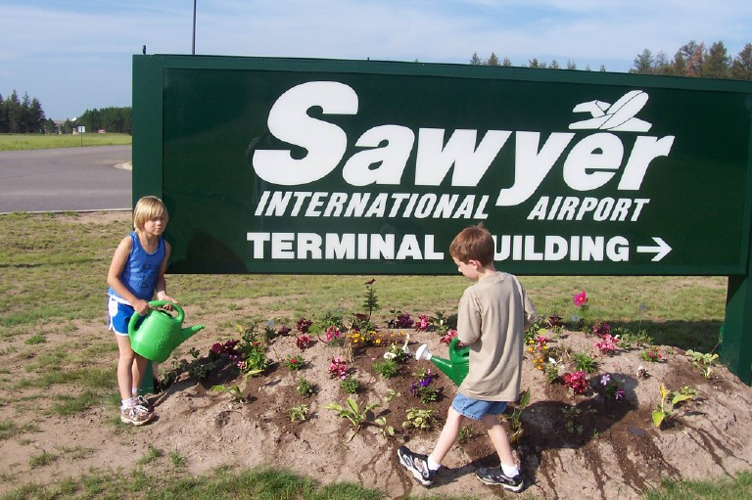

Community Beautification continues successfully as a collaborative effort of K.I.Sawyer Community Association, Forsyth Township, West Branch Township, K.I.Sawyer Learning Center and community volunteers.

SEPTEMBER
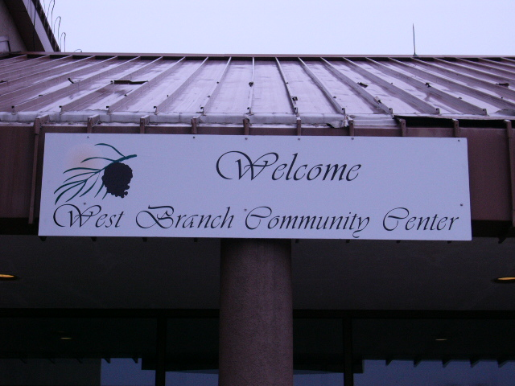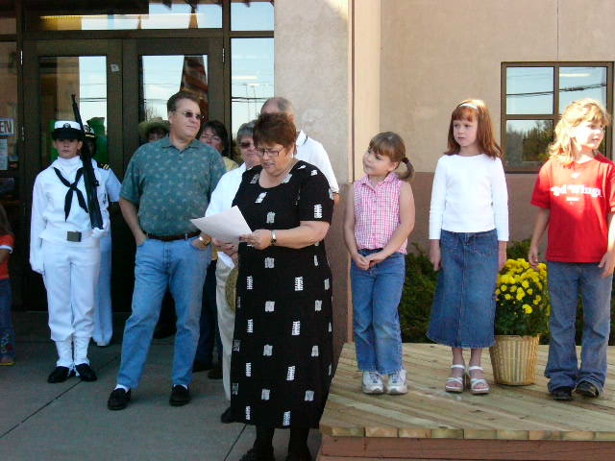

West Branch Township takes over former YMCA facility. Building will continue to house the fitness center, and will include a day care center and other lease tenants. Improvements, including new roof, insulation, front entrance, carpeting, energy efficiency upgrade, and water slide are expected to enhance environment and reduce operating costs.

Forsyth and West Branch Townships conduct Special Mid-Decade Census through Sawyer Operations Authority. Increased population should generate additional township funding from the state of Michigan.

2000 2004
K.I.Sawyer
Total Population 1,443 2,554
% Growth 77%
Median Age 24.7 Years 25.7 Years
Total Households 501 914
Forsyth Twp. at Sawyer 1,712
W. Branch Twp. at Sawyer 842

Something Brewing Coffee Shop opens at 304 Avenue A. Owners Herb Parsons, Ray Amtmann and spouses will offer freshly roasted coffee, specialty coffees, homemade baked goods, and light meals.

Presbyterian Self-Development of People Grant to assist Sawyer Community with updated community dialogues, “The K. I. Sawyer News”, and other community projects.

OCTOBER
Community Association hosts community-wide forum at Salvation Army Recreation Center to discuss pending water rate increases as Marquette County becomes owner/operator of the Sawyer water and wastewater systems.

“K. I. Sawyer News”, started at the grassroots level in 1998, expands to an 8-page newspaper with local advertising. Publication is a cooperative effort between K.I.Sawyer Community Association and “The Marquette Monthly”.

Sawyer Operations Authority named a finalist in Governor Granholm’s “Cool U. P. Projects” initiative. Community Development Project finalist selection based upon uniqueness, public/private partnerships, economic impact and ability to attract/retain Generation X and Y.
“If you can dream it, you can do it.”
Walt Disney

Telkite, Inc. makes first $1 million payment to Marquette County. In exchange Telkite takes ownership of the four-building ACN complex. Telkite is scheduled to pay several million more over the next five years in exchange for more than 1,450 acres and 1.5 million square feet of building space at K.I.Sawyer for the development of Telkite Technology Park.

NOVEMBER
Victory Lutheran Church hires Karen Hattamer as Youth Director.

Naval Reserve Facility, reservists and community members gather to celebrate the Navy’s 229th birthday.

Gwinn-Sawyer Medical Clinic and Marquette General Health Systems begin quarterly “Lunch and Learn” health lecture sessions for seniors at the Tailwinds.

Mark Sippola, son of Victory Lutheran Pastor Mark and Barb Sippola, leaves to walk across America to raise money for the “House for the Hattamers’ project. Sippola, a personal friend of the late Staff Sgt. Stephen Hattamer who was killed in action on Christmas Day, 2003 began his walk in Columbia, South Carolina, Hattamer’s first military assignment, and intends to finish in Spokane, Washington where Hattamer is buried.

DECEMBER
Gas station scheduled for spring groundbreaking. At a site across from the Red Fox Inn on M-94 West, Neil Armatti and Marquette County’s EDC will collaborate on this gas station/deli/convenience store.

Community Association receives 4th year funding from Catholic Campaign for Human Development.

Sawyer’s Fourth Annual Tree-Lighting Ceremony is now scheduled in conjunction with Gwinn and Little Lake events. Santa and Mrs. Clause stop by the Coordination Office where K.I.Sawyer Seniors serve refreshments.

JANUARY
Patricia and Robert Friot open a state-licensed adult foster care home called Evergreen at their Dagger Street residence.

Saving American Veterans’ Equity Charitable Trust (SAVE) opens office in West Branch Community Center (The “W”). SAVE’s goal is to eliminate foreclosure of veterans’ homes.

FEBRUARY
Medical Care Access Coalition grant will result in a volunteer medical clinic in space donated by Catherine A. Kroll, DO, Gwinn-Sawyer Medical Centers.

“Plane Talk” sessions scheduled at K.I.Sawyer Learning Sessions. K. I. Sawyer Heritage Air Museum and Sawyer Learning Center are teaming up. The Museum group is loaning the Learning Center a number of books, and Learning Center youth will receive the advantage of hearing about Sawyer’s history from retired AF personnel.

Volunteers needed for a Neighborhood Watch Program.

Superior Arts Council presents “Love Songs from the Heart”, a Valentine weekend musical dinner theater and matinee at the Sawyer Center.

MARCH
Doreen Takalo opens Reenies Consignment Shop at 304 Avenue A. Located inside Something Brewing Coffee Shop, the store features gently used clothing for men, women and children.

Salvation Army Recreation Center hosts Scout lock-ins, St. Patrick’s Day pool tournament, exercise and Red Cross classes, youth basketball and other programs.

Successful 2005 Law Enforcement Torch Run Polar Plunge at Little Trout Lake and follow-up activities at the Tailwinds Grill and Bar raises substantial funds for Special Olympics.

APRIL
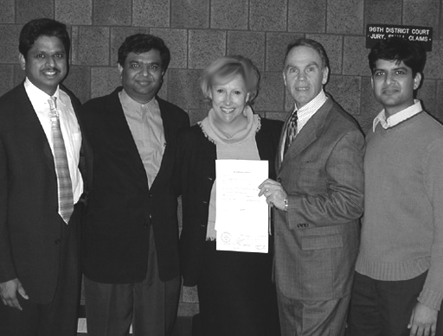
Marquette County Board approved a revised $4 million agreement with Telkite, Inc. for a marketing contract and sale of Sawyer properties. Telkite officials state their intentions to invest $20 million in Sawyer’s redevelopment over the next ten years.

Community Association continues “Coffee and Conversation” community dialogue process; sponsors Bay College Leadership Training course; facilitates “The Sawyer News” journalism classes.

David McNeill, loyal K. I. Sawyer Learning Center volunteer, died as the result of a local car accident.

Sawyer International and Northwest Airlines announce new flight service to/from Minneapolis beginning in June, 2005.

MAY
Potlatch acquires Louisiana-Pacific lumber mill. Potlatch, which is a diversified forest products company with timberlands in Arkansas, Idaho and Minnesota, plans to make initial capital investments that are expected to improve the mill.

Mike Bennett hired as new Director of West Branch Community Center.

Community Garden concept is well underway at the “W”. AmeriCorps worker Denise Nurkala is working with area youth to plant and grow about sixty flats of flowers and vegetables that will be maintained through the local Beautification Project and/or given away to residents.

Gwinn-Sawyer Chamber of Commerce will host its fifth annual charity golf outing at Red Fox Run Golf Course in June. All proceeds are donated to local youth programs.

Charles Street, one of Sawyer’s most dedicated volunteers and Facility Manager for the Community Coordination Office leaves the area with his wife Carole to re-locate near his children.

Episcopal Diocese of Northern Michigan offers assistance with Sawyer’s community development efforts.

West Branch Community Child Care Center receives $15,000 Michigan 4C Start-up Grant and $50,000 USDA Rural Development Grant to prepare for child care program. Center is expected to open by mid-summer, 2005.

K. I. Sawyer Reunion scheduled for June 24-26, 2005 expected to draw visitors from across the country. A full program of activities is planned.
“It’s amazing what one can do when one doesn’t know what one can do.” Garfield the Cat

Garfield the Cat

The accomplishments at K.I.Sawyer are truly amazing—accomplishments not by one, but by many. Stay in touch; get involved. The best is yet to come!

